* Showing the table of flight

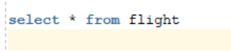

Output

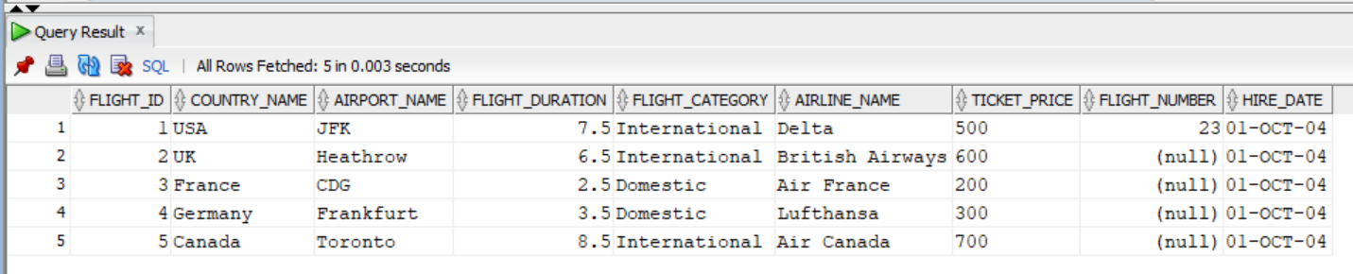

* **Activity 2:**

Use of Number Functions

1. **Calculate the remainder of ticket price:**

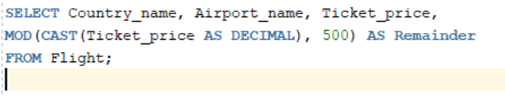

Output:

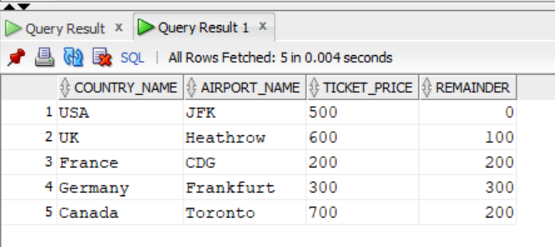

1. **Check How Truncation Works**

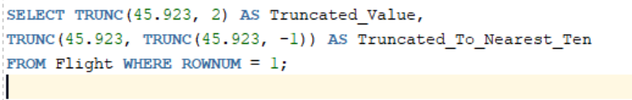

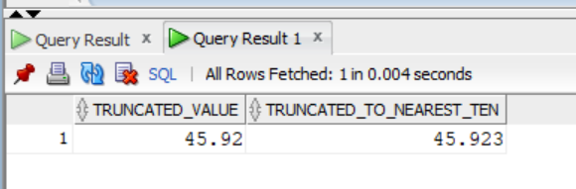Output:

1. **Check How Rounding Works**

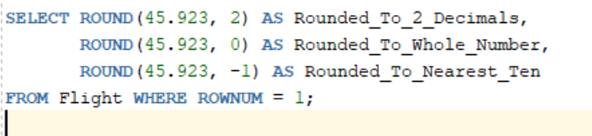

Output:

